INSTITUTO POLITECNICO NACIONAL
CET 1 “WALTER CROSS BUCHANAN”

STUDY GUIDE
TERCER SEMESTRE
2013-2014 A

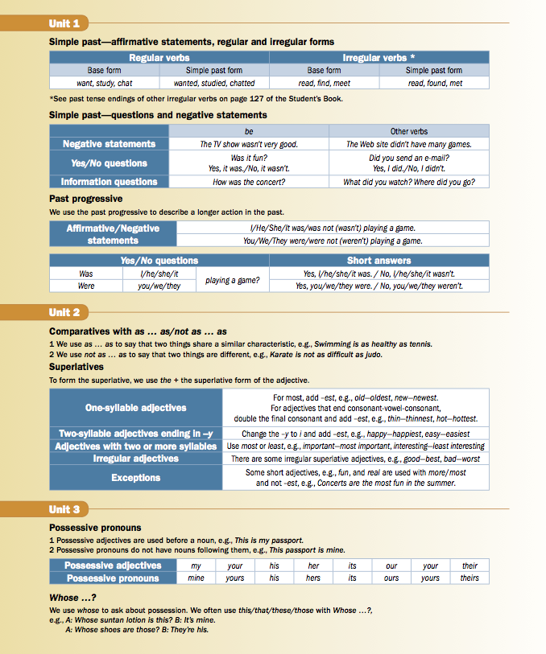

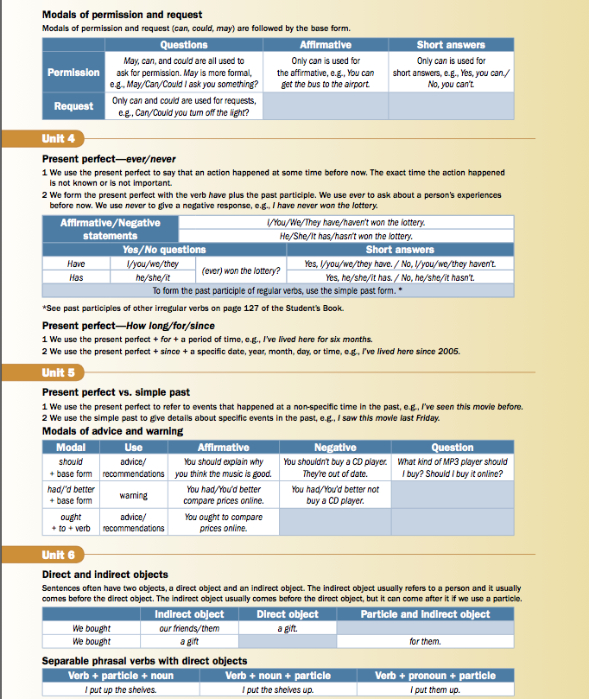

STUDY GUIDE
3rd Semester
VOCABULARY

1. Write the correct verb forms.

A: Hi, Sam. I (1) ______(see) you last night at the library. What (2) ________ you _______ (do)?
B: I (3) _____________ (look) for some information for our history report. I (4) __________ (not find) anything.
A: I (5) ______________ (find) some great information on the Internet.

2. Circle the correct words.

My cousin had (1) an accident / a place / a test last week. He was on a bus to the airport when it happened. He told me he was very (2) exhausted / proud / scared when it happened. He wasn't hurt, but he (3) found / lost / missed his plane. When he finally got to the airport, he realized he also (4) found / lost / won his wallet. He went to the police station and talked to many different officers. Finally, he found it, but he was (5) confused / exhausted / uncomfortable.

3. Circle the correct words.
I had a horrible morning. First I put (1) away / out / up all Peter's things and I hung (2) away / out / up his clothes.
Then I cleaned (3) away / out / up the kitchen and I had to clean the (4) shower / stove / toilet. Then I cleaned the shower in the (5) bathroom / bedroom / dining room.

4. Circle the correct words.
I'm very upset (1) for / by / in an article I read on a famous (2) blog / e-mail / search engine. It said young people spend too much time playing (3) blogs / movie files / online games. I was very surprised (4) on / at / by the writer's opinions. He doesn't know anything about young people. I'm worried (5) about / at / by the older generation.

5. Circle the correct words.
My uncle Fred was a (1) dumb / incomprehensible / well-liked comic. Everyone loved him. He had a comedy (2) class / exhibition / show that traveled all over the country for years. He was very (3) boring / popular / inexplicable in small towns. One time he tried to put some culture in his act. He added a (4) ballet / exhibition / sculpture. It was very (5) amazing / dull / modern. Everyone fell asleep.

6. Complete the sentences with the following words.
ANGRY | BLOG | INTERESTED | SURFING | SURPRISED

My father is very (1) ____________ in the Internet. He spends hours (2) ____________ the Internet and he writes a (3) ____________. I was very (4) ____________ by his reaction to an article I sent him about older people and the Internet. He was very (5) ____________ about it.

7. Complete the sentences with the following words.
foreign, incomprehensible, modern, museum, strangest
I saw the (1) _______________ movie last night. I usually like (2) ______________ movies, but this one was (3) ________________________. I didn't understand anything. I saw it at an art (4) _________________. I guess (5) ________________ movies are more complicated than the old ones.

GRAMMAR

1. Circle the correct words.

Henry! It's very late. Go to your room and (1) clean it up / clean up it / it clean up now. Then (2) away throw the things / throw away them / throw away the things you don't need. We can (3) away give them / give away them / give them away. Mark (4) an invitation sent you / sent an invitation you / sent you an invitation to his party next week. We have to buy (5) a present him / him a present / buy him it.

2. Circle the correct words.

A: (1) Did anyone see / Did anyone seen / Has anyone seen Coldplay in concert?
B: Yes, (2) I saw / I've see / I've seen them a couple of years ago.
A: (3) Did it be / Has it been / Was it good?
B: Of course. They're coming back next month. You (4) had better / ought to / should come with me.
A: (5) You'd better / You ought / You should remind me. I forget everything.

3. Write the correct verb forms.
A: Where (1) ____________ (be) John and Betty last night?
B: They (2) ____________ (study) for the exam. I (3) ____________ (try) to call you, but you (4) ____________ (not answer).
A: I (5) ____________ (watch) a movie at Bob's house.

4. Circle the correct words.
A: (1) Can't / Do / May I look at this magazine?
B: It isn't (2) mine / their / yours.
A: Whose magazine (3) am / are / is it?
B: I don't know. You (4) can / do / may ask Bob. Maybe it's (5) mine / his / ours.

5. Write the correct verb forms.
A: What (1) _________ you _________ (do) around 10 o'clock yesterday morning? You weren't at the computer center.
B: I (2) ____________ (want) to play tennis, but it (3) ____________ (rain) so I (4) ____________ (stay) home. And you?
A: I (5) ____________ (study) for my exam.

6. Write the correct verb forms.
A: Hi, Sam. I (1) ______ (see) you last night at the library. What (2) _______you ________ (do)?
B: I (3) _______________ (look) for some information for our history report. I (4) _______________ (not find) anything.
A: I (5) _____________ (find) some great information on the Internet.

7. Write the correct verb forms.

A: What (1) _______Henry ____________ (do) when you (2) ____________(have) your accident?
B: He (3) _________________ (work). I (4) ______________ (call) him and he (5) _____________ (drive) me home from the hospital.

8. Complete the sentences with the following words.
can, could, his, these, yours
A: Whose tickets are (1) ___________?
B: It think they're (2) __________. Hey, Will. (3) ____________ I ask you something?
C: Of course you (4) ____________.
B: Are these tickets (5) ____________?

READING

6. Read the text and circle the correct words.
The Pirates of the Caribbean movies are my favorite movies of all time. I like them because they mix action, humor, and special effects. The actors are great, too. Johnny Depp's Captain Jack Sparrow is perfect. He's a mixture of a pirate and a rock star. Orlando Bloom is also good, especially in the first movie. The funniest part of the first movie was when Jack had to escape from the soldiers and he stole the ship all by himself. The other two movies were also good. I enjoyed them. I really liked the special effects and make-up. They say the movies were made for children, but I think they're incredible.

The critic saw (1) one movie / two movies / three movies. He thought the (2) first / second / third movie was the best. His favorite actor was (3) Jack Sparrow / Johnny Depp / Orlando Bloom. He interpreted his role by mixing (4) action / humor / two personalities. He enjoyed the (5) actors / music / special effects in the last two movies.

ANSWER KEY

1. Write the correct verb forms.
A: Hi, Sam. I (1) saw (see) you last night at the library. What (2) were you doing (do)?
B: I (3) was looking (look) for some information for our history report. I (4) didn't find (not find) anything.
A: I (5) found (find) some great information on the Internet.

2. Circle the correct words.
My cousin had (1) an accident / a place / a test last week. He was on a bus to the airport when it happened. He told me he was very (2) exhausted / proud / scared when it happened. He wasn't hurt, but he (3) found / lost / missed his plane. When he finally got to the airport, he realized he also (4) found / lost / won his wallet. He went to the police station and talked to many different officers. Finally, he found it, but he was (5) confused / exhausted / uncomfortable.

3. Circle the correct words.
I had a horrible morning. First I put (1) away / out / up all Peter's things and I hung (2) away / out / up his clothes. Then I cleaned (3) away / out / up the kitchen and I had to clean the (4) shower / stove / toilet. Then I cleaned the shower in the (5) bathroom / bedroom / dining room.

4. Circle the correct words.
I'm very upset (1) for / by / in an article I read on a famous (2) blog / e-mail / search engine. It said young people spend too much time playing (3) blogs / movie files / online games. I was very surprised (4) on / at / by the writer's opinions. He doesn't know anything about young people. I'm worried (5) about / at / by the older generation.

5. Circle the correct words.
My uncle Fred was a (1) dumb / incomprehensible / well-liked comic. Everyone loved him. He had a comedy (2) class / exhibition / show that traveled all over the country for years. He was very (3) boring / popular / inexplicable in small towns. One time he tried to put some culture in his act. He added a (4) ballet / exhibition / sculpture. It was very (5) amazing / dull / modern. Everyone fell asleep.

6. Complete the sentences with the following words.
My father is very (1) interested in the Internet. He spends hours (2) surfing the Internet and he writes a (3) blog. I was very (4) surprised by his reaction to an article I sent him about older people and the Internet. He was very (5) angry about it.

7. Complete the sentences with the following words.

I saw the (1) strangest movie last night. I usually like (2) foreign movies, but this one was (3) incomprehensible. I didn't understand anything. I saw it at an art (4) museum. I guess (5) modern movies are more complicated than the old ones.

GRAMMAR

1. Circle the correct words.
Henry! It's very late. Go to your room and (1) clean it up / clean up it / it clean up now. Then (2) away throw the things / throw away them / throw away the things you don't need. We can (3) away give them / give away them / give them away. Mark (4) an invitation sent you / sent an invitation you / sent you an invitation to his party next week. We have to buy (5) a present him / him a present / buy him it.

2. Circle the correct words.
A: (1) Did anyone see / Did anyone seen / Has anyone seen Coldplay in concert?
B: Yes, (2) I saw / I've see / I've seen them a couple of years ago.
A: (3) Did it be / Has it been / Was it good?
B: Of course. They're coming back next month. You (4) had better / ought to / should come with me.
A: (5) You'd better / You ought / You should remind me. I forget everything.

3. Write the correct verb forms.
A: Where (1) were (be) John and Betty last night?
B: They (2) were studying (study) for the exam. I (3) tried (try) to call you, but you (4) didn't answer (not answer).
A: I (5) was watching (watch) a movie at Bob's house.
4. Circle the correct words.
A: (1) Can't / Do / May I look at this magazine?
B: It isn't (2) mine / their / yours.
A: Whose magazine (3) am / are / is it?
B: I don't know. You (4) can / do / may ask Bob. Maybe it's (5) mine / his / ours.

5. Write the correct verb forms.
A: What (1) were you doing (do) around 10 o'clock yesterday morning? You weren't at the computer center.
B: I (2) wanted (want) to play tennis, but it (3) was raining (rain) so I (4) stayed (stay) home. And you?
A: I (5) was studying (study) for my exam.

6. Write the correct verb forms.
A: Hi, Sam. I (1) saw (see) you last night at the library. What (2) were you doing (do)?
B: I (3) was looking (look) for some information for our history report. I (4) didn't find (not find) anything.
A: I (5) found (find) some great information on the Internet.

7. Write the correct verb forms.
A: What (1) was Henry doing (do) when you (2) had (have) your accident?
B: He (3) was working (work). I (4) called (call) him and he (5) drove (drive) me home from the hospital.

8. Complete the sentences with the following words.
can, could, his, these, yours
A: Whose tickets are (1) these?
B: It think they're (2) his. Hey, Will. (3) Could I ask you something?
C: Of course you (4) can.
B: Are these tickets (5) yours?

READING

6. Read the text and circle the correct words.
The critic saw (1) one movie / two movies / three movies. He thought the (2) first / second / third movie was the best. His favorite actor was (3) Jack Sparrow / Johnny Depp / Orlando Bloom. He interpreted his role by mixing (4) action / humor / two personalities. He enjoyed the (5) actors / music / special effects in the last two movies.

